CHRISTMAS BAKING SODA SCIENCE EXPERIMENT

THIS WAS THE MOST AWESOME CHRISTMAS BAKING SODA SCIENCE EXPERIMENT YET!
Last year’s Christmas baking soda science cookie cutters activity was also great fun, but this is definitely a must-try activity! Make a great science lesson with erupting holiday ornaments! We especially enjoy baking soda fizzy eruptions any time of the year.
We have tried many different baking soda science variations over the past year and have a whole collection of baking soda science fizzy favorites! Baking soda and vinegar science activities are perfect for young kids and provide a hands on learning experience too. We love anything that fizzes, bangs, and pops!
SUPPLIES
plastic globe ornaments with removable tops
baking soda
vinegar
food coloring {optional}
glitter and sequins {optional but always better with glitter!}
container to catch fizz
turkey baster or eye dropper
funnel for filling ornaments {optional but helpful}
plastic drop cloth or newspaper is handy for mess control
SIMPLE SET UP
I used a 5 compartment party serving tray to hold the ornaments. You could also use an egg carton. I put about a tablespoon of baking soda in each compartment and dusted it all with glitter. I used a funnel to fill each ornament with about 2 tablespoons of baking soda, more glitter and some sequins!
Mix up a big container of vinegar and food coloring. Add a turkey baster. We used probably 6 cups by the end! Place newspaper or a plastic cloth down to catch the fizz. We really made these ornaments erupt big time!

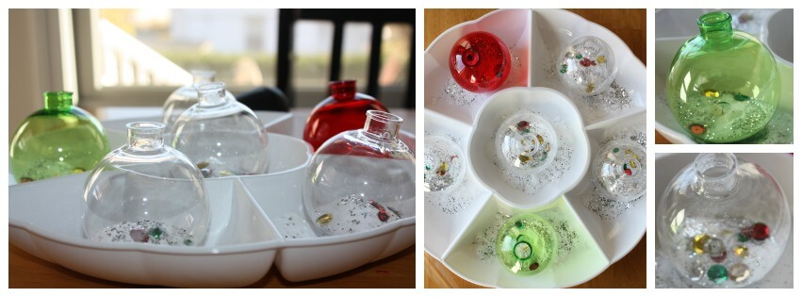Save
We used the turkey baster to transfer the vinegar to the ornaments! This was also excellent fine motor skills practice! My preschooler understands that the fizzy bubbling action is actually a reaction from the two materials, a base and an acid (baking soda and vinegar), mixing. We explained a bit further this time that a gas is released called carbon dioxide. Want to know more, click here.

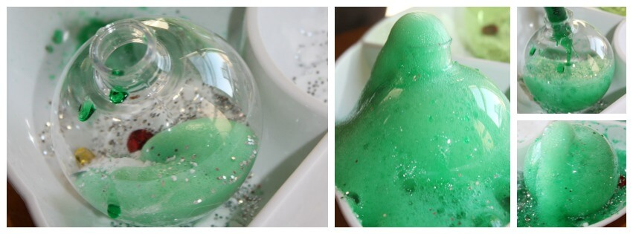Save
We were totally surprised when it shot right out of the ornament and all over the place, including his tummy! Of course, we had to do this again and again. You might want to make sure you have enough vinegar handy! It is a magical sight for kids.
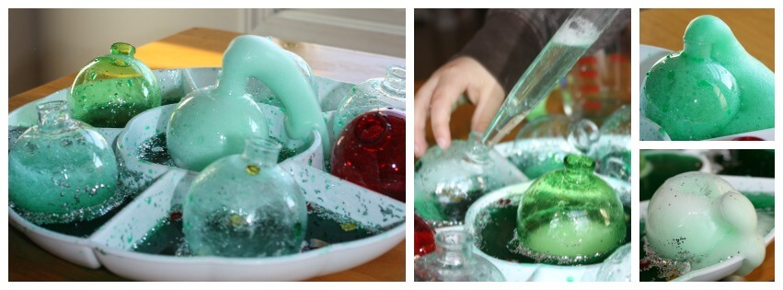Save
We refilled the ornaments and performed the baking soda and vinegar over and over until the tray couldn’t hold anymore!

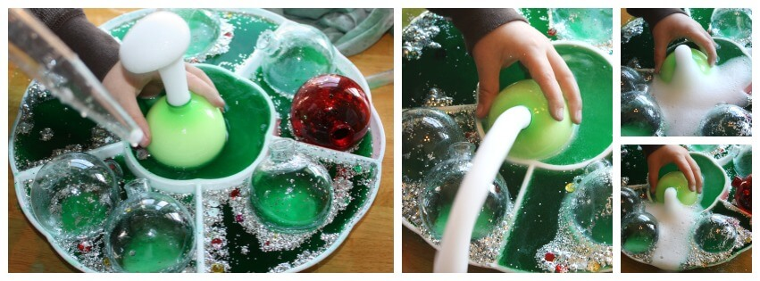Save
I would have to say our holiday themed science experiment was a complete success and a treat for both of us to spend time with this morning! Make the Christmas season extra special. Try out our Christmas Science Countdown!

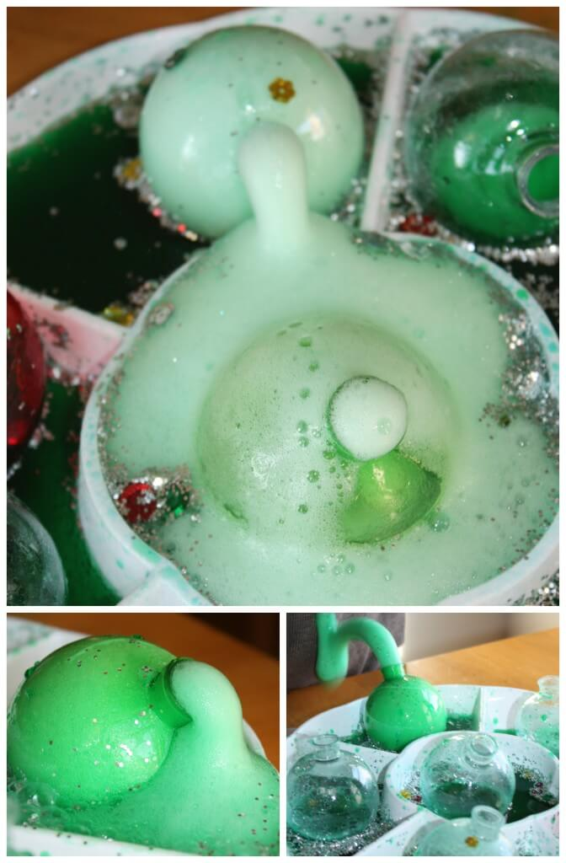Save
He looked pretty darn cute making these ornaments erupt and loved the reaction the baking soda and vinegar produced. Check out how it hit his tummy! He thought that was the coolest {so did I}. We love Christmas themed science ideas.

