- TUITION: I/We do hereby agree to pay the total annual tuition, to be paid monthly in accordance with the attached tuition rate sheet. This tuition is due regardless of attendance. Lack of attendance for any reason does not change the tuition due. NO credits or reductions of fees will be made for days my child(ren) does not attend the program. The entire school calendar has been taken into consideration and the fees are based on all days the school is open for children to attend. This will include any extension to the calendar required by snow days not built into the calendar. Based on my enrollment date of ______________________ I/We understand the annual tuition will be $_________________ and the monthly payment will be $____________________. First months payment is due at the time of enrollment.

- I/We understand that in order to start the first day of school I must complete all paperwork and pay the first month prior to August 15th.

- I/We understand that SNOW DAYS are included and I will be able to drop my child off at the Designated Carelot Children’s Center at no additional cost to me.

- ANNUAL FEE: I/We will be required to pay a non-refundable annual fee of $50.00 per family

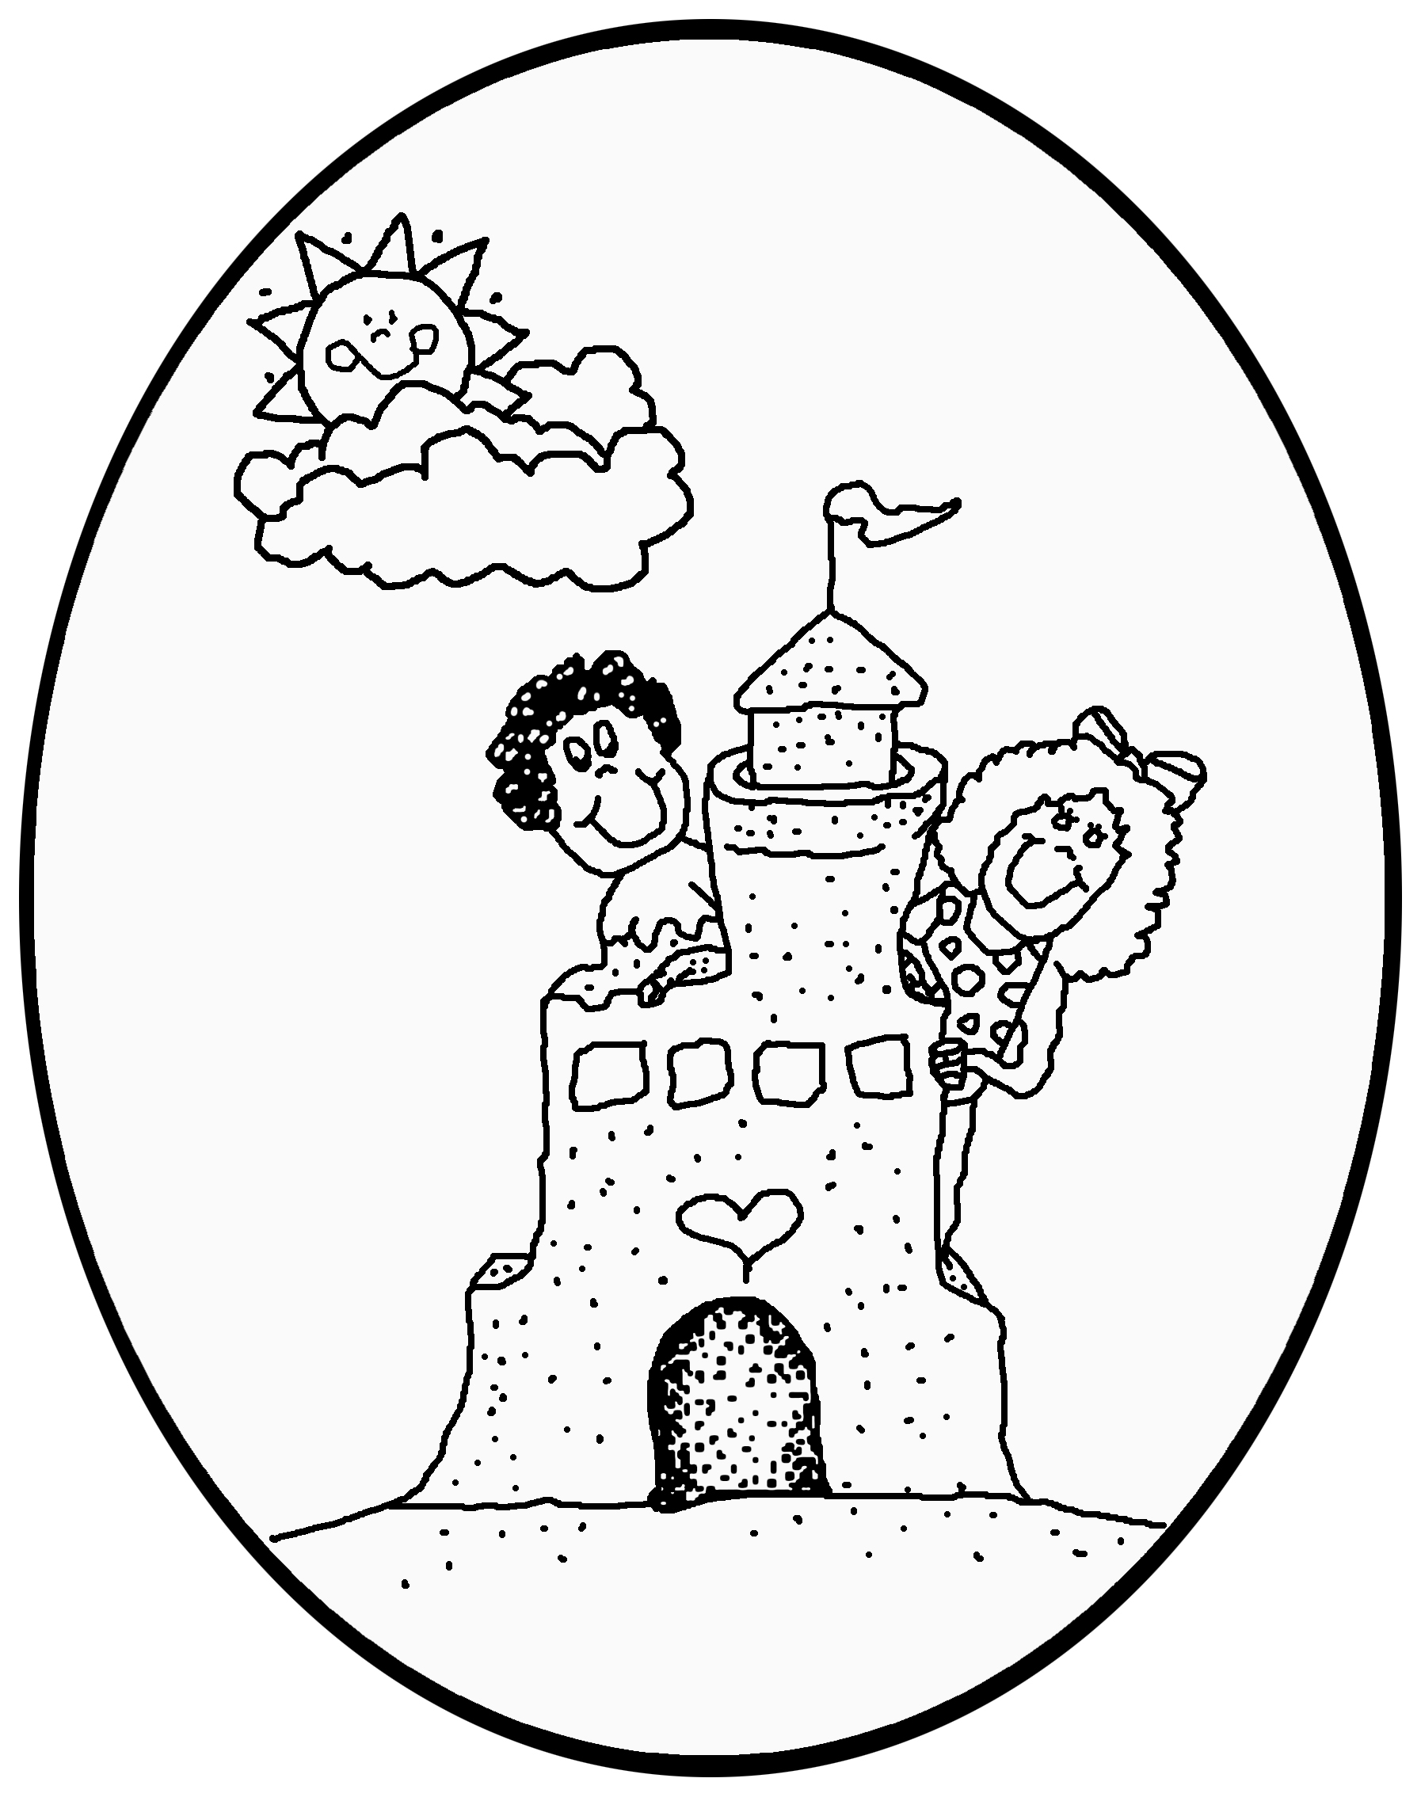
- PAYMENTS DUE BY: I/We will pay my monthly tuition fee by the 15th of the prior month. (For example, October’s payment is due by September 15th) All payments received after the 15th of the month will be subject to a $25.00 late fee. This fee will be automatically added to the account on the 16th of the month. If my payment is not received and my account paid in full by the 1st of the month my child(ren) will not be accepted into the program.

- LATE FEES: A $25 late fee will be charged weekly on an account until the account balance is paid in full. Late fees will be billed regardless of whether the child(ren) attends the program that day.

- ADDITIONAL FEES MAY APPLY: I/We understand that the tuition amount listed in #1 is due each month throughout the year regardless of personal vacation weeks/days off or school vacation weeks. If I/we choose to take advantage of extra days or hours during Vacation weeks, Professional Development Days, Summer Break and Holidays that the Public Schools are closed and Clubhouse and Centers are open, my/our account will be charged accordingly for this extra time.

- NSF FEES: I/We will pay the service charge of $25.00 for all returned checks and understand that if three (3) checks are returned I/we will be required to make cash payments only.

- CREDIT CARD ON FILE: I/We understand that payment must be paid in full when discontinuing services for any reason. Below is an accurate credit card authorization form to keep on file that upon withdrawal the entire account balance will be applied to the card if payment is not received in full by the last day care is provided.

Credit Card Information: (please print clearly)

Name as it appears on the credit card:__________________________________________________________________
Billing Address: _________________________________________________________________________________
City: _______________________________ State: __________ Zip Code: ____________
Telephone: ( _____ ) ______________ Cell: (_____) _________________Email: _______________________________
Select type of card: □ VISA □ MASTERCARD
Card Number:________________________________________________________________
Expiration Date ____/____ 3 digit security code _________ (found on back of card)

I authorize Carelot Children's Center to charge the above Credit Card for any outstanding balance due on my account upon withdrawal. The card listed will only be used should I withdraw and have an outstanding balance. I understand the 2.5% convenience fee will be applied.
_________________________________________________ __________________
Signature Date

- FAMILY NAMES AND SS#:
Child Name_________________ SS# ________________________ Child’s Name:__________________ SS# ___________________
Mother/Guardian’s Name: __________________________________________ SS # ________________________________
Father/Guardian’s Name: _______ ___________________________________ SS# _________________________________
*I/We have read and understand all the policies stated above and agree to abide by these policies*

__________________________________________________________________________________________
Parent/Guardian Signature Date Parent/Guardian Signature

